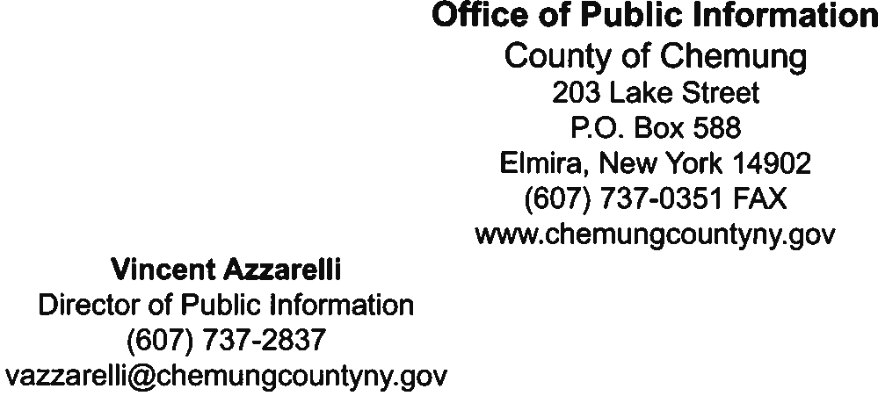
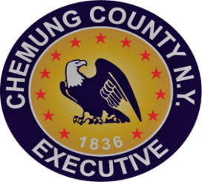

FOR IMMEDIATE RELEASE
DATE: September 20, 2020
RE: Chemung County FREE COVID-19 Testing for Chemung County Residents September 21 – 23

Contact: Vincent Azzarelli, Chemung County Public Information Director @ 737-2837

The Chemung County Health Department (CCHD), in coordination with the New York State Department of Health (NYSDOH), will be offering a free COVID-19 drive thru testing to Chemung County residents due to our recent increase in cases.

To be tested you must preregister, fill in the required information, wear a mask, and have photo ID. Members attending from the same household need to register separately. Testing will be offered from noon to 6 pm on Monday, September 21, and from 11 am to 5 pm on Tuesday, 9/22, and Wednesday, 9/23.

Participants should remain in their car with windows up at all times, with photo ID placed on dashboard.

Register at: https://www.chemungcountyny.gov/covid_testing/index.php

Testing for COVID-19 leads to quick identification of cases and immediate isolation of the person to prevent further spread in our community. Confirmed cases and close contacts to positive cases are quarantined to further reduce spread. Testing is a vital tool for public health to monitor the COVID-19 infection rate as well as to reduce the impact of our current cluster.

The testing at this site is free, it does not require a doctor’s order, and the CCHD or NYSDOH will call you with results in about 2 to 4 days. It is possible to have COVID-19 with minimal or even no symptoms at all. That is why it is important that people receive testing.

If you have any questions please feel free to call the Chemung County health Department at 737-2028

